Provider relations
Kepro
Adding New Users to Your Provider Groups
A Step-by-Step Process
The provider group administrator will log in and select “Setup” at the top of the screen. This takes you to a setup screen.
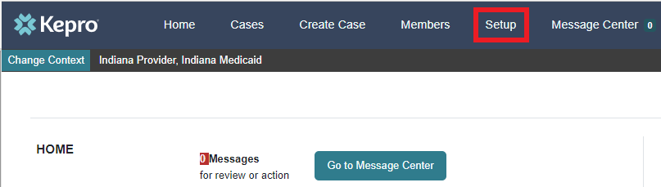
Select the drop-down carat to manage the specific provider group you wish to add a user to.
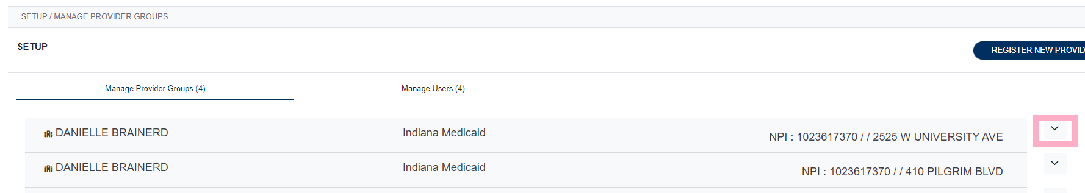
You can either add from existing users or you can add a new user and select the role the user will have with this provider group.
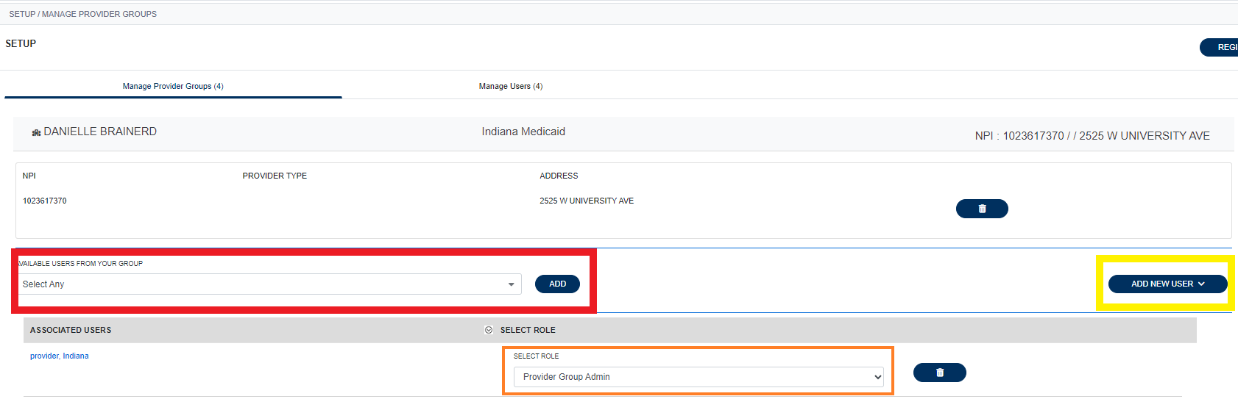
Select a user from the “AVAILABLE USERS FROM YOUR GROUP” and then select ADD”.
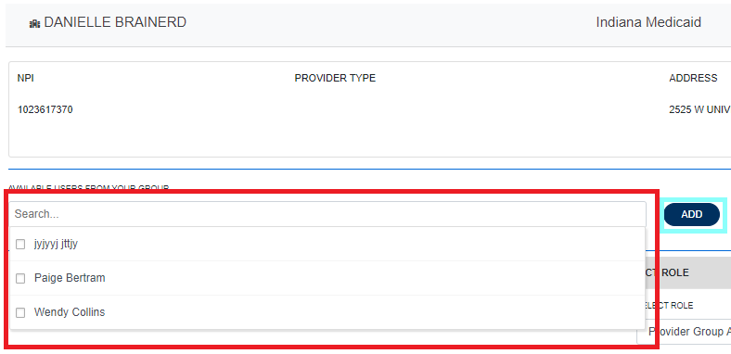
You will then see the user associated with that provider group.
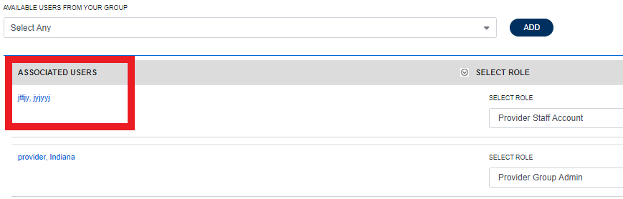
To add a new user, select “Add New User” and then fill out the information needed and “Create”.
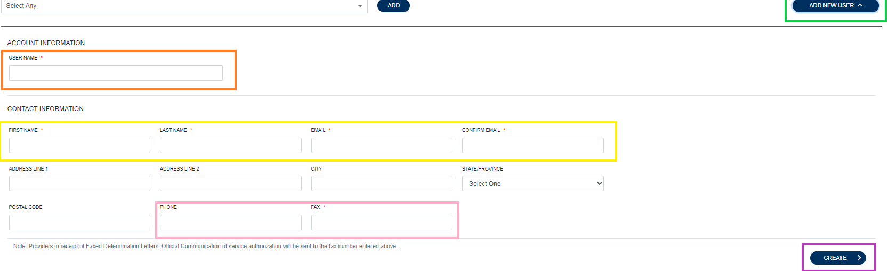
The system will notify you if a username is available. 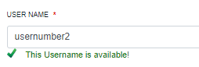
You will then see your new user listed under the users tab. If you need to add them to other providers, you will need to select “Manage Provider Groups” and follow the process to add from current users.
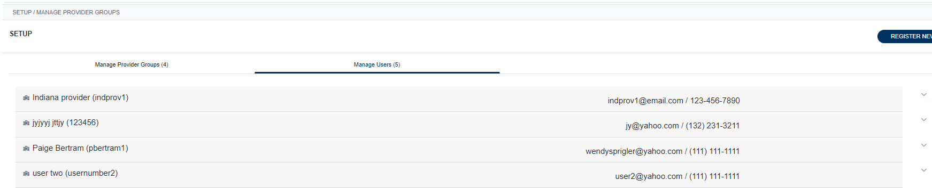
You can only add users from the “Manage Provider Groups” tab by selecting the drop-down carat.

