A helpful Guide to case submission
DME
_{Step by Step Process}
Provider Relations
Acentra

Select “Create Case” at the top of the screen- select “UM”-then select “Outpatient” and “Go to Consumer Information”.
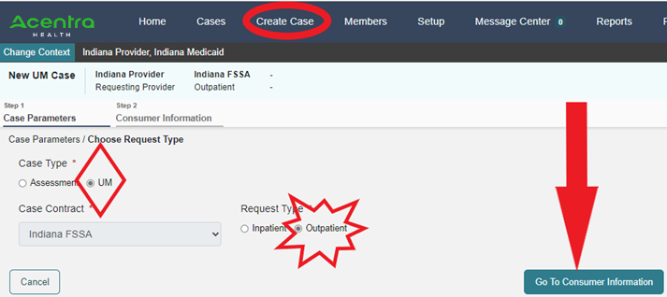
Enter either the Member ID # OR the First Initial Last Name and DOB of the member on the next screen. Then select search.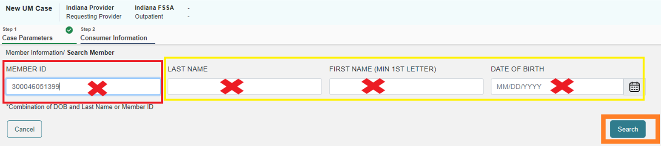
Select the member by clicking on “Choose”.
This will populate a screen that will show any cases the provider has submitted for that member. This is a good place to ensure it will not be a duplicate request. Then select “Create Case”.

On the next screen, the user will be able to “Add Attending Physician”. The user will need to verify that they are requesting under the correct provider context and update the servicing provider to a billing or group NPI if they are requesting under a rendering provider NPI. Next select the “Go to Service Details” button.
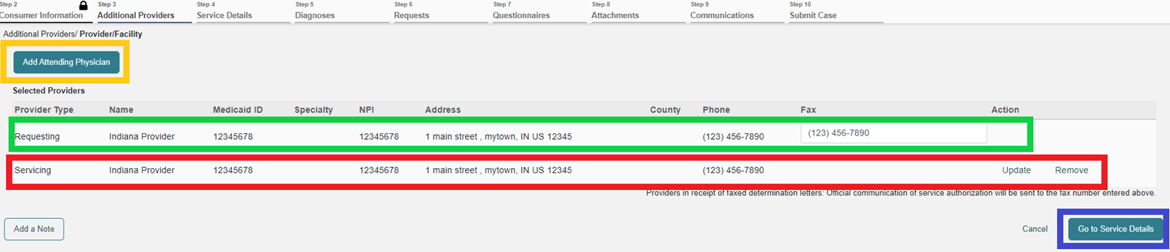
On this screen the user will select the “Service Type” of “DME” (11). Then select “Go to Diagnosis”.
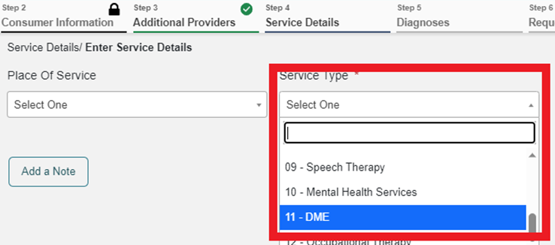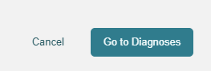
Click your mouse in the “Search” box that says, “Select a Diagnosis Code”. 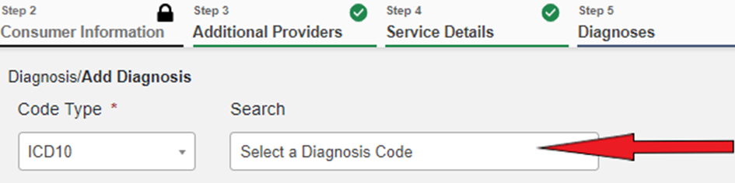
Once the box opens, enter at least 3 characters to search. This can be added by number or description. Select the diagnosis. The chosen diagnosis codes will populate to be selected, and then select “Go to Requests”.
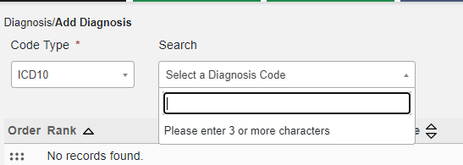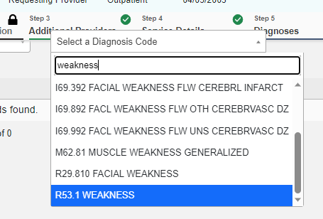
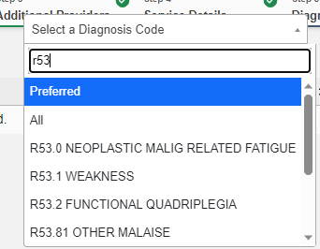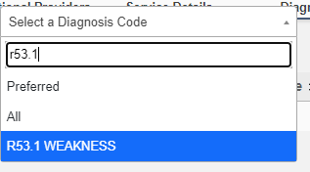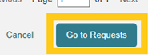

Then select “Prior Auth” under “Request Type”. (“Retrospective” if it is a retrospective review). Then select “Go to Procedures”.
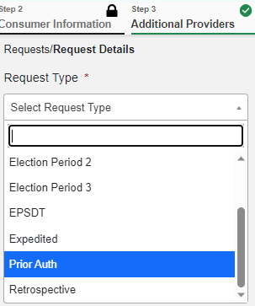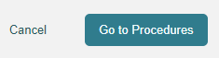
Search the first code needed by clicking in the box that says, “Search by code or description”. A selection of CPT codes will populate. Then select the code from the list & after a moment the screen will populate to fill in “Requested Start Date”, “Requested End Date”, “Requested Duration” & “Requested Quantity”. There will be a pop up that reminds the user of forms that may be required. This is informational and does not impact submission.
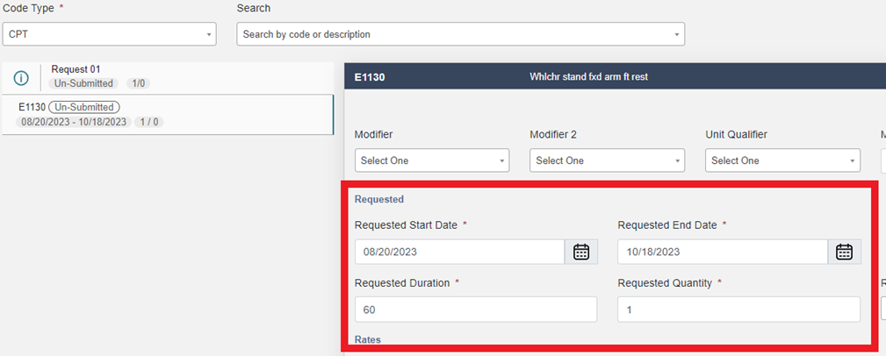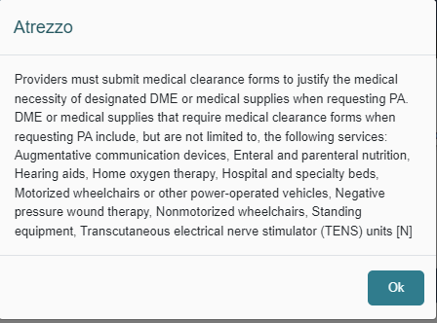
Next select “Go to Questionnaires”.
On the next screen select “Go to Attachments”.
Click “Upload a document”. Select the “Document Type” from the drop down and either “Drag and Drop OR Browse Your Files”. Do this for each document type uploaded.
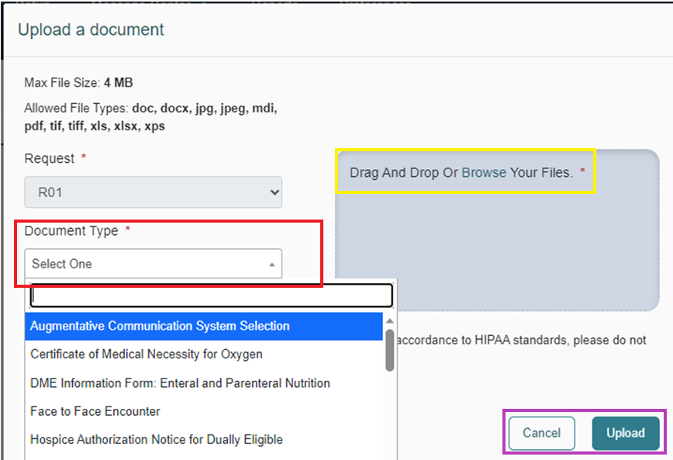
Next select “Go to Communications”.
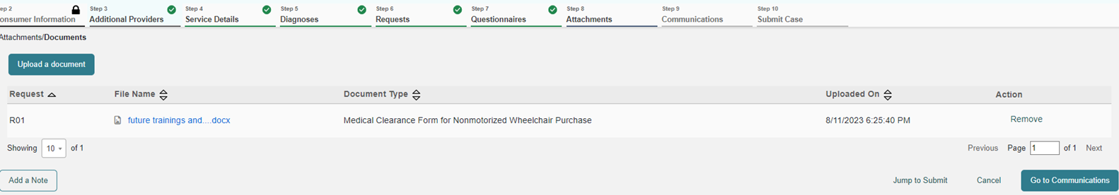
Users can then “Add a note” if there is additional information not in the documentation that the user feels the reviewer may need to know.
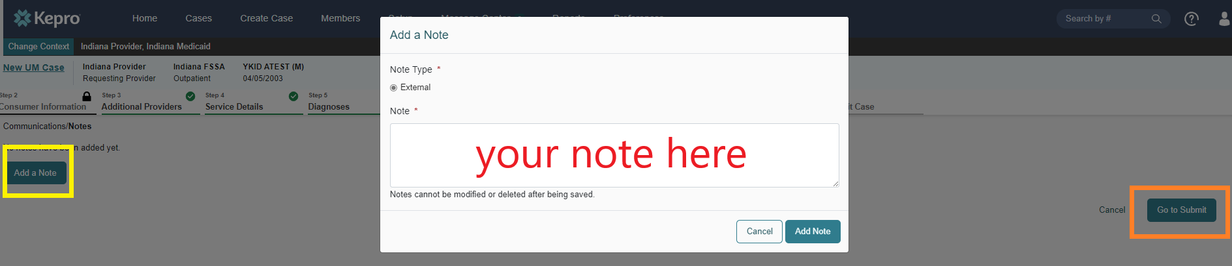

Next the user will then see a summary page, where they can update any portion of the submission that does not display correctly. When correct, select submit.
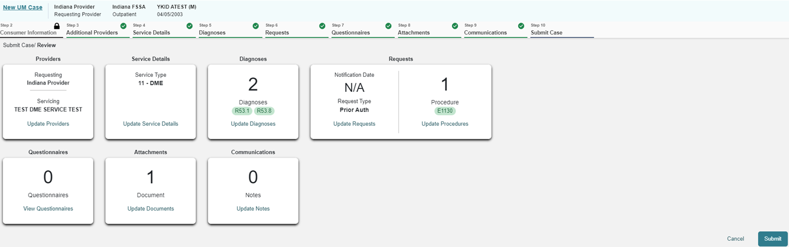
The user will be taken to the case screen that will show “Submitted” in bright pink. Occasionally it will show as “Complete” if it was auto approved.

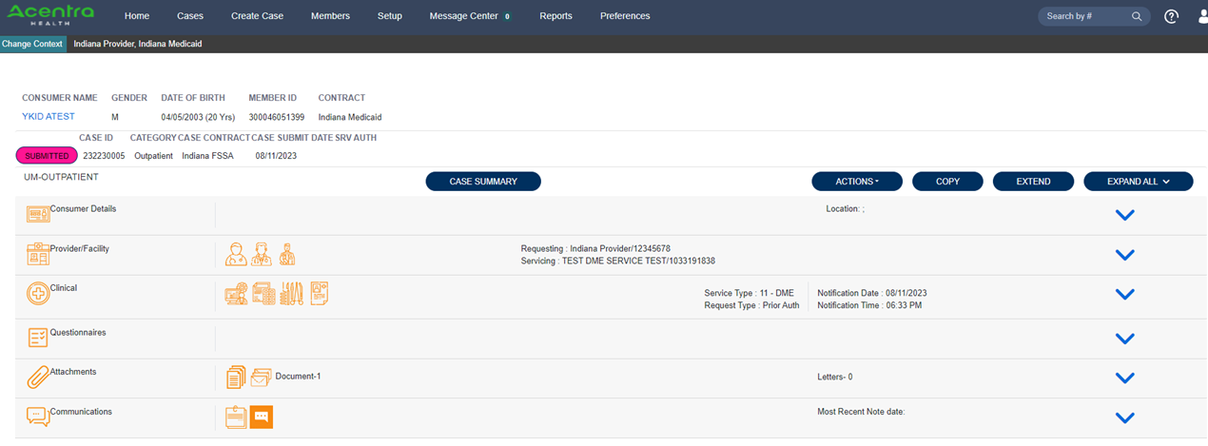
When the case is in review, the user will receive status updates as the case changes status and when the letter is available for viewing. To view the letter, select the expansion carat next to “Attachments”. Letters will be displayed there with a hyperlink to open and download.

When a provider needs to extend the authorization for new DOS when the authorization has not yet expired, this should be done using the Extend option. Providers can do this from the case queue or from within the case.

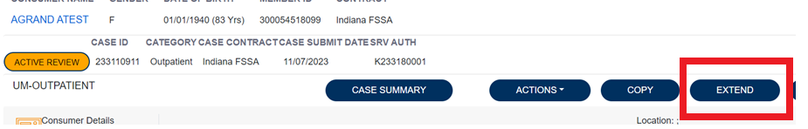

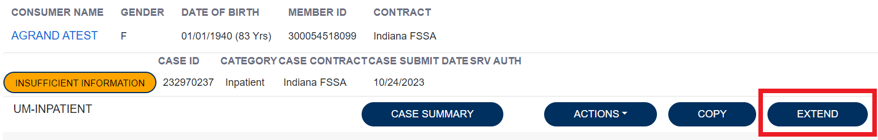

Here, the provider will need to expand the clinical section of the case and enter the quantity and duration in the new request line. And additional documentation should be attached as well.

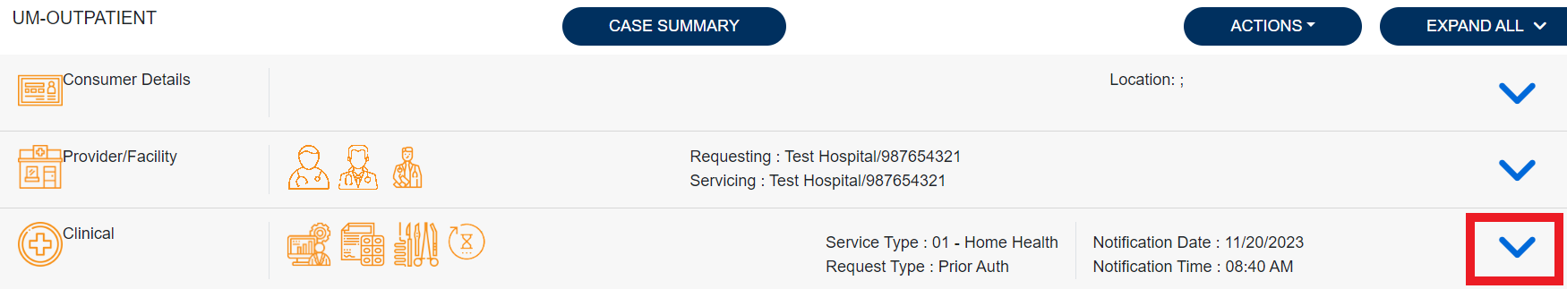
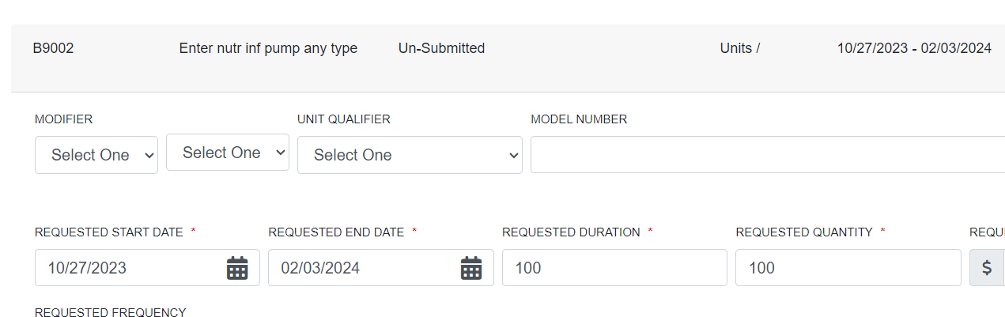

Next the provider will check the box regarding Understanding that the PA is not a guarantee of payment and is for medical necessity only. And then click submit.
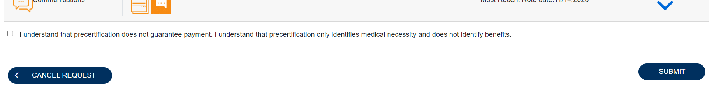
Below are some important links:

Training videos and other materials specific to Indiana Medicaid FFS are available at:
https://INMedicaidFFS.kepro.com
New Provider Portal Link:
https://portal.kepro.com
Standard system training materials are available at the Atrezzo Help site:
https://www.kepro.com/atrezzo-help
FSSA forms link:
https://www.in.gov/medicaid/providers/provider-references/forms/
Modules for providers:
Indiana Medicaid: Providers: IHCP Provider Reference Modules
Provider Fee Schedules:
Indiana Medicaid: Providers: IHCP Fee Schedules
Contact Support Center:
- INPriorAuthIssues@acentra.com
- Phone: 866.725.9991
- Fax 1-800-261-2774

