Dental Step by Step Process
STEP BY STEP PA SUBMISSION PROCESS
PROVIDER RELATIONS, ACENTRA
Select “Create Case” at the top of your screen- select “UM”-then select “Outpatient” and “Go To Consumer Information”.
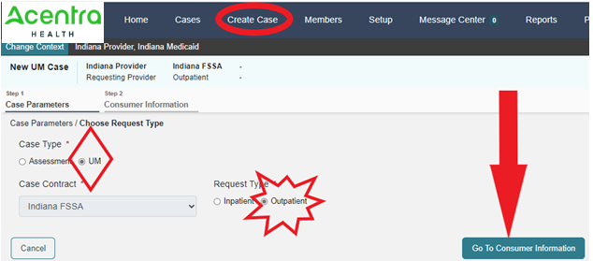
Enter the “Member ID” or First/Last name and DOB
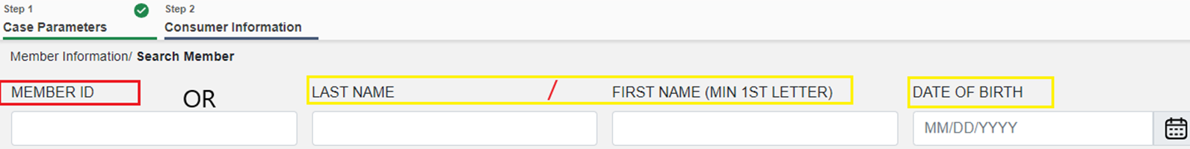
Then “Search” and choose your member:
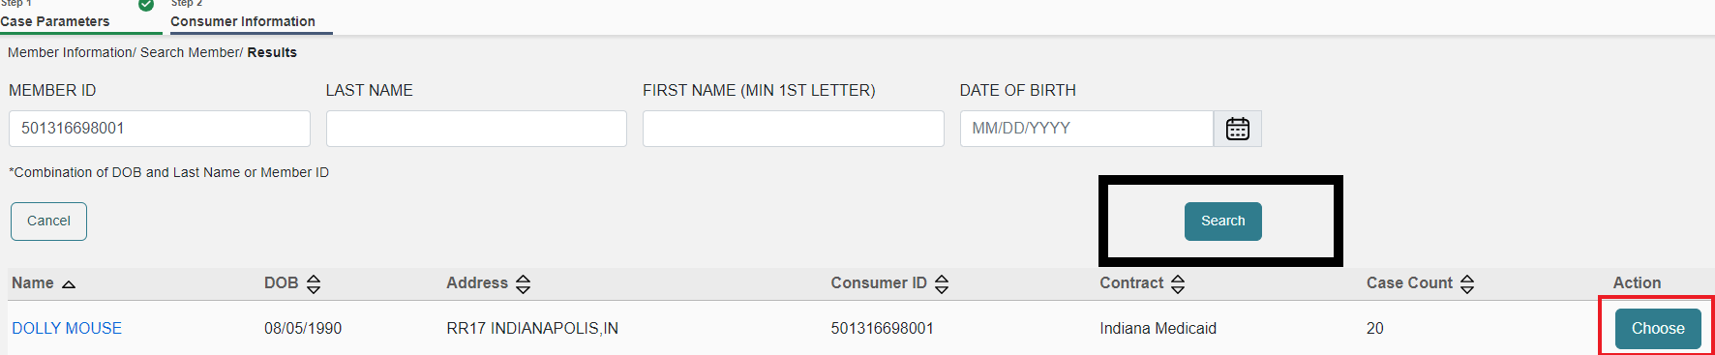
Your screen will display any cases you have submitted for this member, double check that you are not submitting a duplicate and then choose “Create case”.
On the next page verify that your provider information is correct. Please be sure that the servicing provider NPI is a group or billing NPI, this is required by the FSSA. Then click “Go to Service Details”.
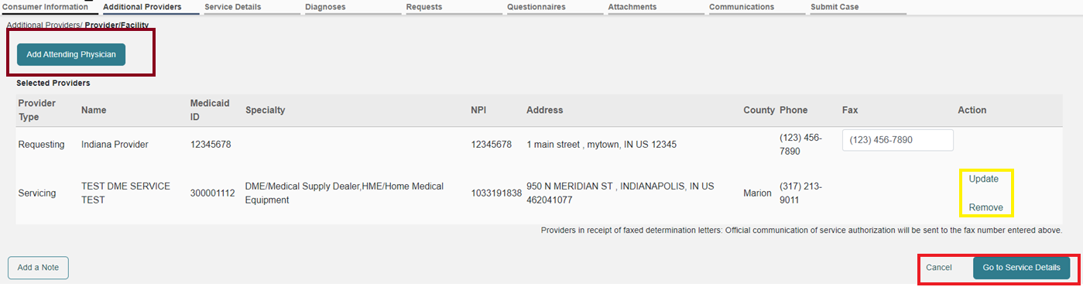
Any field that is denoted with a red *is a required field. The others are not required. Select “Dental” (15) as your “Service Type” and then click go to diagnosis.
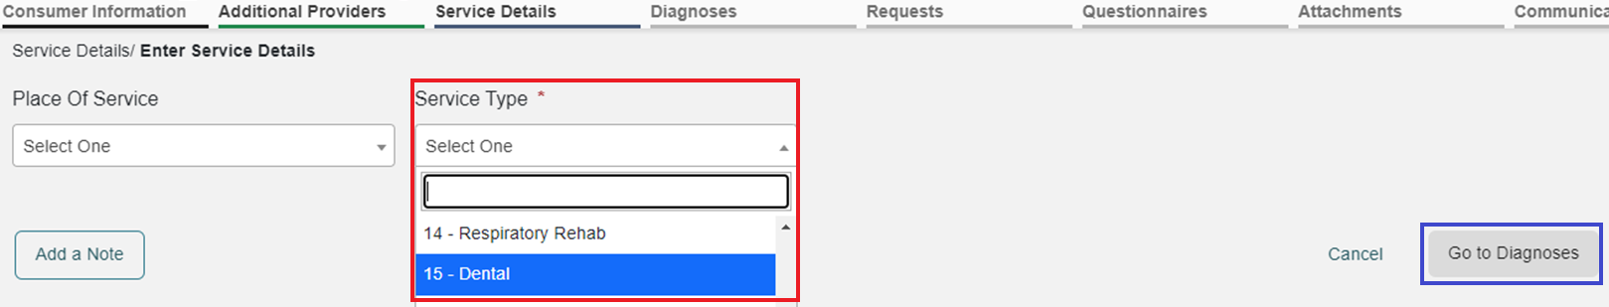
For this field, we have noted that many dental providers do not utilize ICD10 codes. The FSSA has approved the code R69 as an acceptable placeholder ICD10 code. Please enter the chosen ICD10 code in the search box, after a moment or two the code will populate below, and you will select it. Once you have selected the code, it will populate below. If you have multiple codes repeat the same process. Then click “Go to Requests”.
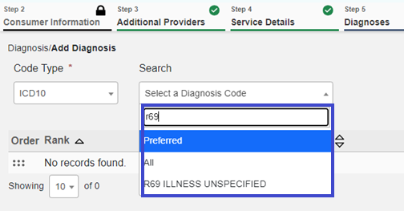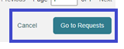
Next you will select the request type, this would be prior auth. Once you select prior auth, click go to procedures.
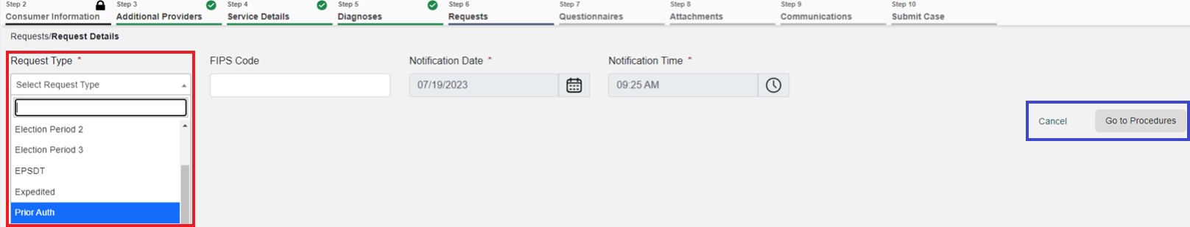
Next you will need to enter your procedure codes. CDT codes will be entered under CPT.
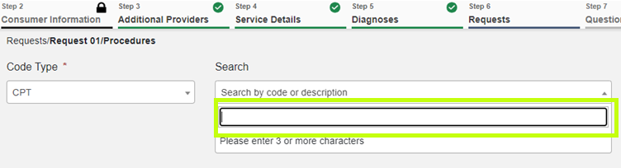
Select your code from the drop down.
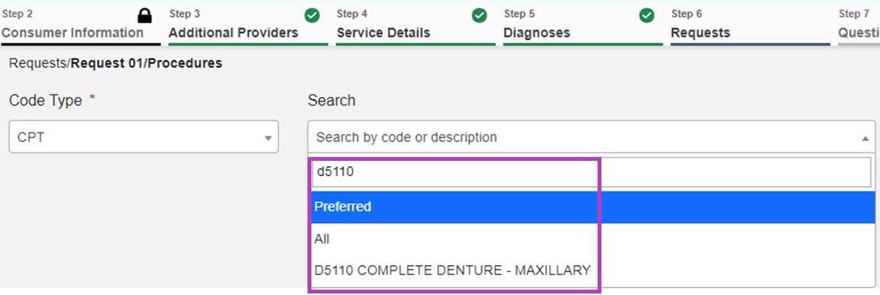
The screen will be refreshed to show the procedure code and fields of entry for specific information (I.E. DOS, Quantity, etc.)
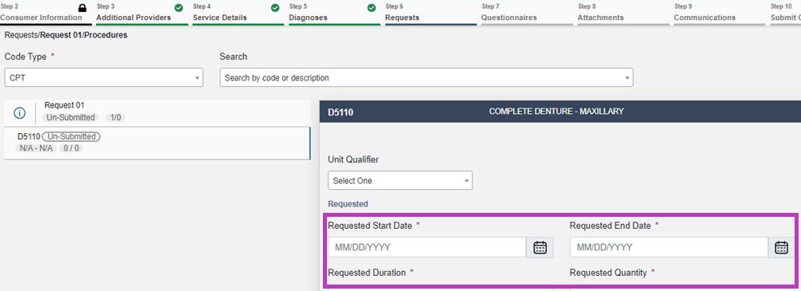
Again, only items noted with a red * are required fields.
The requested start and end date will denote the length you want the authorization to span. Once the start date is entered, you can enter a number in the requested duration (I.E. 90) and this will auto populate an end date for you.
You will next click go to questionnaires, there will not be a questionnaire for dental, so you will then click go to attachments. Click upload a document.
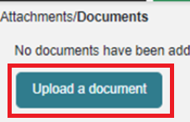

Here you can upload any clinical documents/PA forms. Click upload once load and repeat this for as many documents as needed.
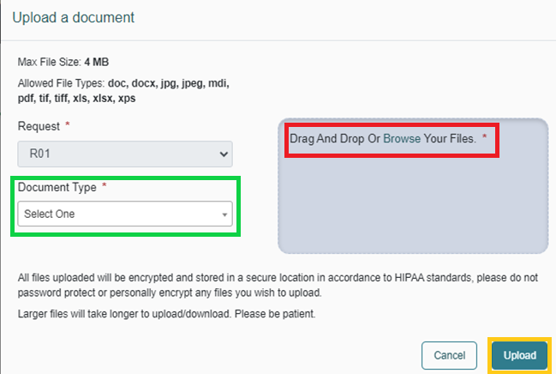
At this point you can either click got to communications if you need to add a note to the clinical reviewer or you may select jump to submit if you are ready to review and submit. To add a note at any time during your submission you can click add note on any tab and this will save the clinician to see.
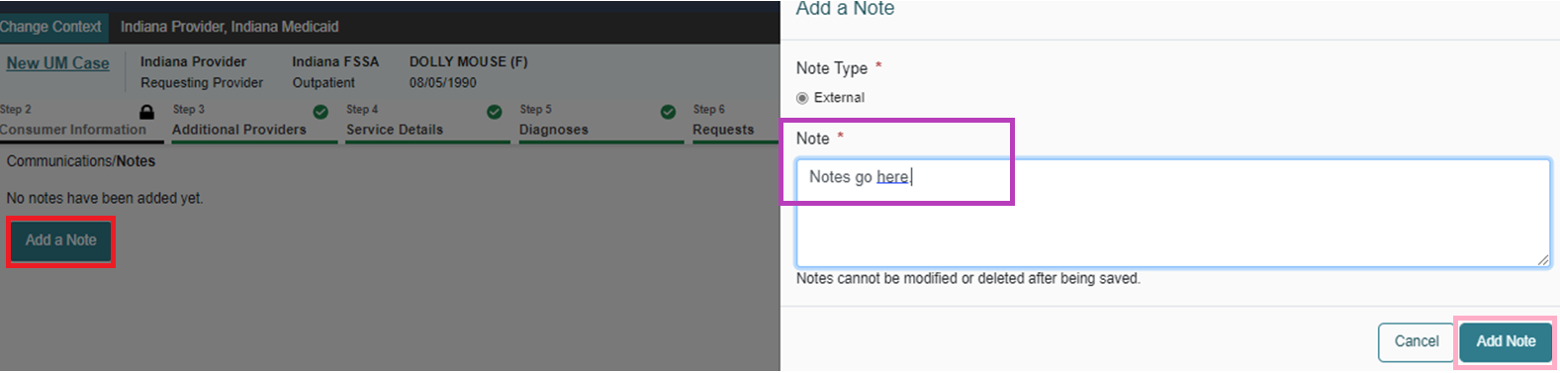
The last screen is an overview. You can select the hyperlink in any of the boxes to go back into that section and update if needed.
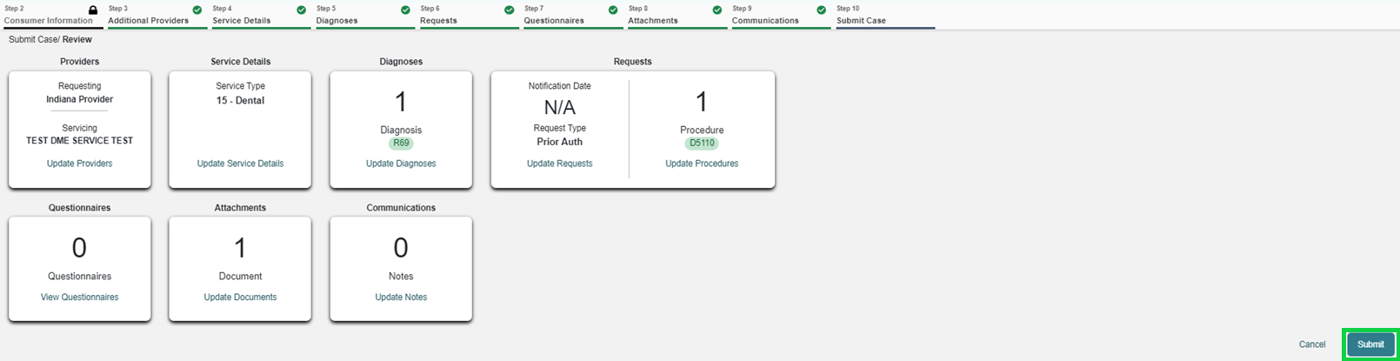
Once you are satisfied with your entries, click submit. You will see a disclaimer regarding medical necessity vs. benefits. Click agree.
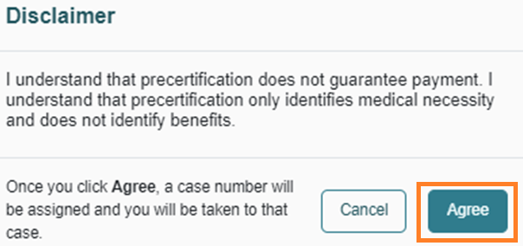

If your case requires clinical review, you will see the Pink Submitted Box top right. If it was auto approved you will see a Complete. Each category is expandable.
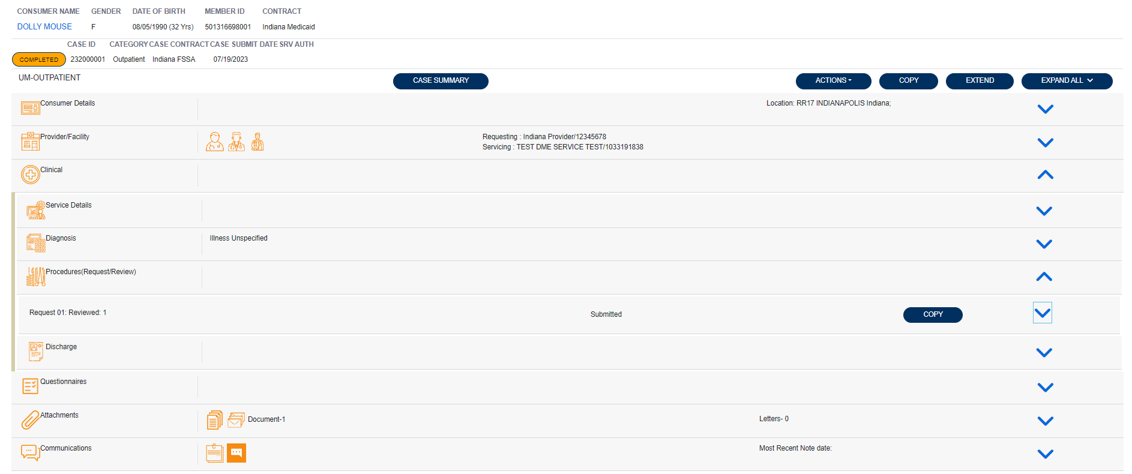
When your case is in review, you will receive status updates as the case changes status and when your letter is available for viewing. To view your letter, select the expansion carat next to “Attachments”. Letters will be displayed there with a hyperlink to open and download.

Important links:

Training videos and other materials specific to Indiana Medicaid FFS are available at:
https://INMedicaidFFS.kepro.com
New Provider Portal Link:
https://portal.kepro.com
Standard system training materials are available at the Atrezzo Help site:
https://www.kepro.com/atrezzo-help
FSSA forms link:
https://www.in.gov/medicaid/providers/provider-references/forms/
Modules for providers:
Indiana Medicaid: Providers: IHCP Provider Reference Modules
Provider Fee Schedules:
Indiana Medicaid: Providers: IHCP Fee Schedules

Contact Support Center:
- INPriorAuthIssues@Acentra.com
- Phone: 866.725.9991
- Fax 1-800-261-2774

