Home Health Step by Step Process  [Document subtitle] | A helpful Guide to case submission  Provider Relations  ACENTRA

Go to “Create Case” at the top of the screen. Choose “UM” then “Outpatient”.
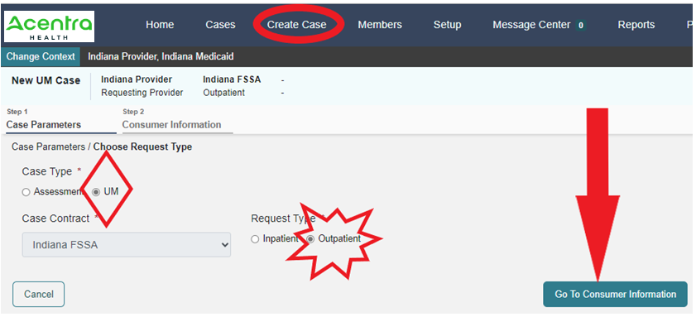
Click Go to Consumer Information. Select by using either the Member/Consumer ID or last name, at least first initial and DOB.
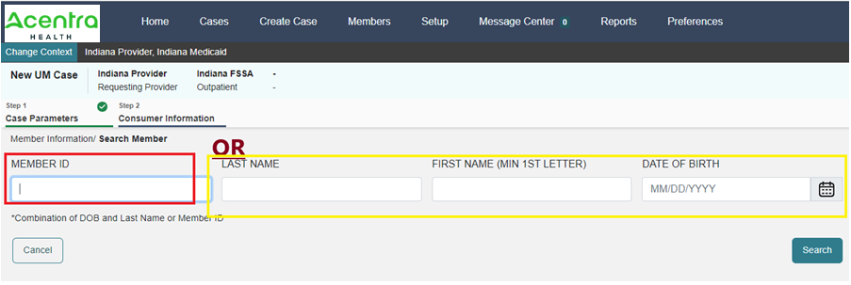

Select the member.
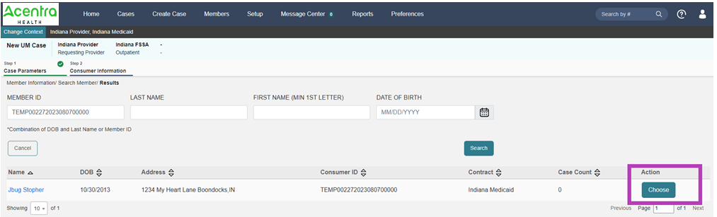
It will display any cases the provider context is associated with for that member. If it is not a duplicate, select create case:
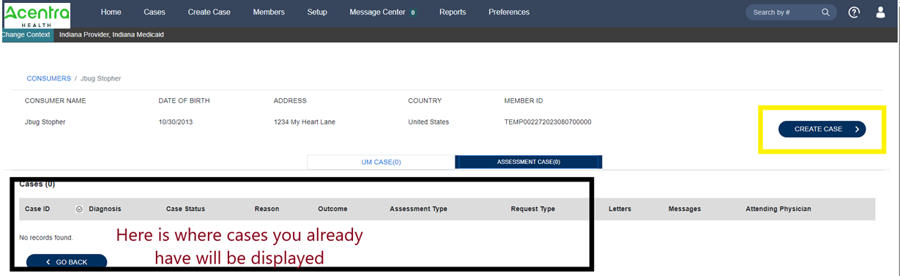

Next the providers will display. The servicing provider can be changed here if needed to be sure a group or billing NPI is listed for claims purposes. The case will not be able to be submitted if it is not a group/billing NPI.
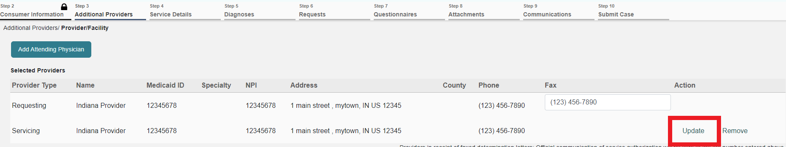
Next select go to services.
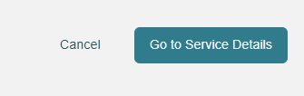
Next select the service type. (Only those sections with a red * are required sections). Select Home Health.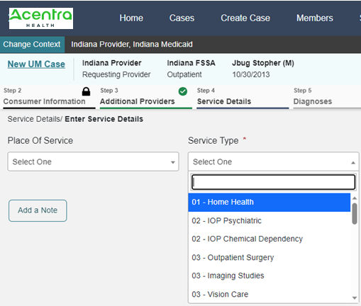
Next will be the diagnosis section. The user needs to enter at least 3 characters for the system to search. Please be patient as it takes a moment to filter.
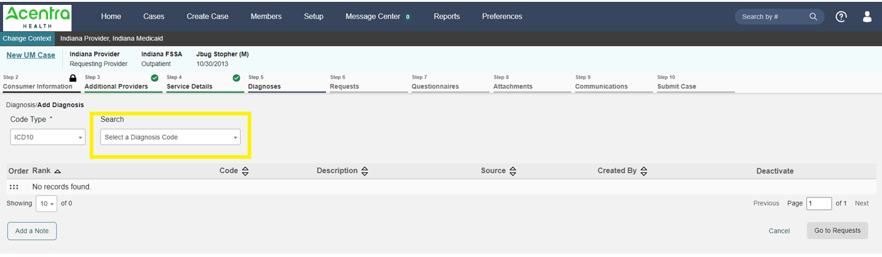
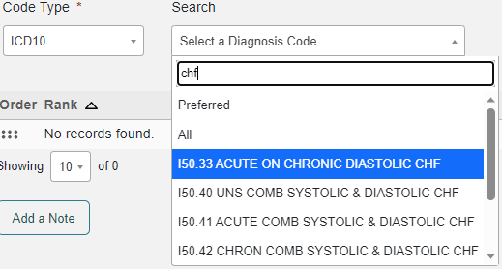
Enter as many diagnoses as needed by using the search window and adding them one at a time.
Next click Go to requests.
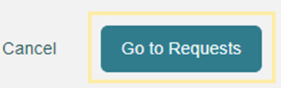
Next choose request type of prior auth. Then go to procedures.
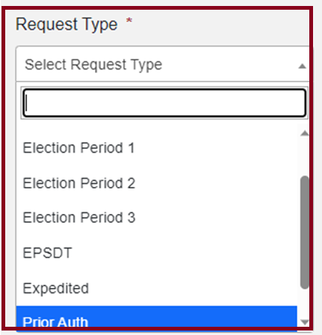
Next the user will enter the CPT codes. Enter a line for each service being requested (I.E., 99600 must be entered twice, once for each for HHA and HHN.)
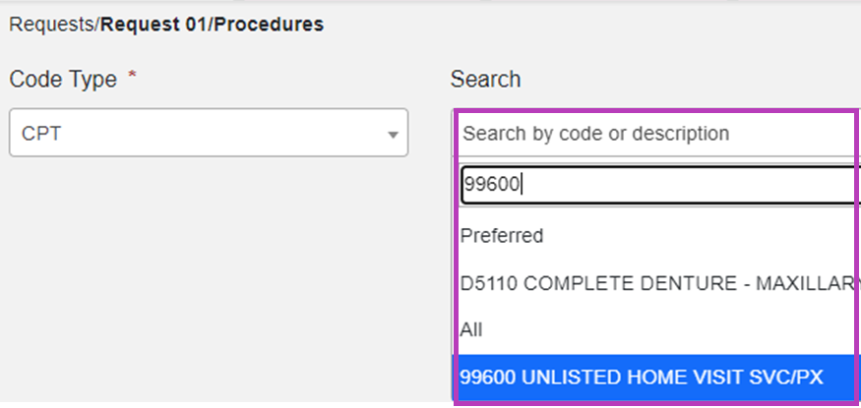
Once selected it will take a moment, but it will load. The user will then enter all the required information for duration and quantity.
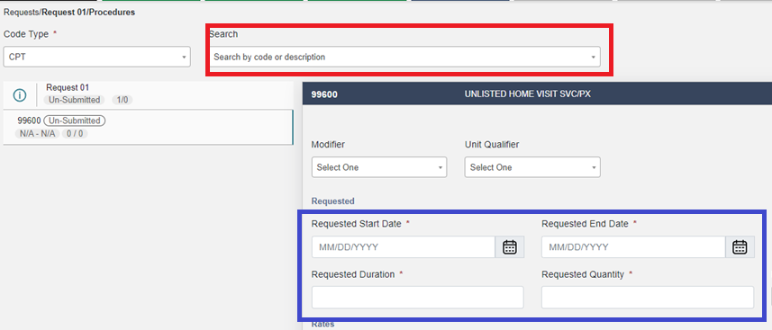
Next, select go to questionnaires.
And then go to attachments.
Here you will upload all of the required documentation.
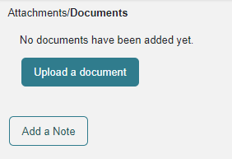
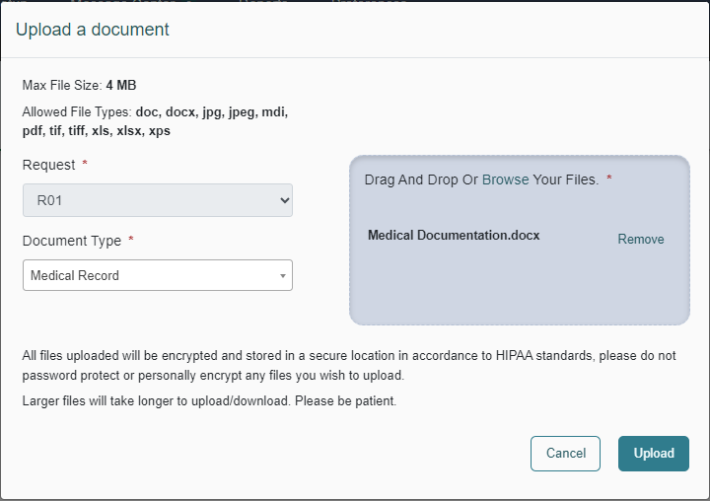
Then click go to communications. If the user needs to add a note, they can do this here. A note can be added to any other section that has the add note button.
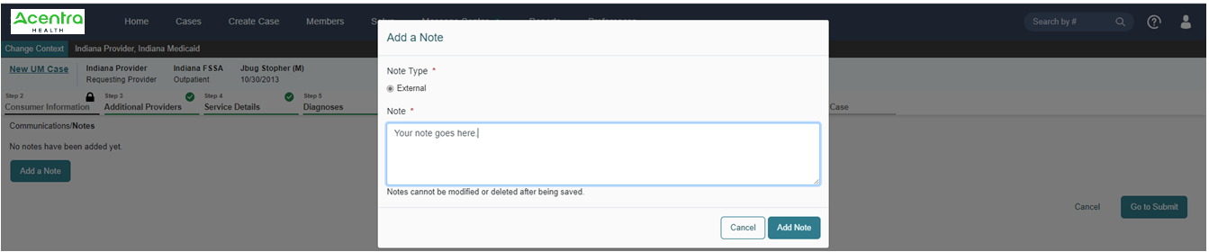

Then click go to submit. Next a summary page of entries displays. The user can click on any updates to review any selection.
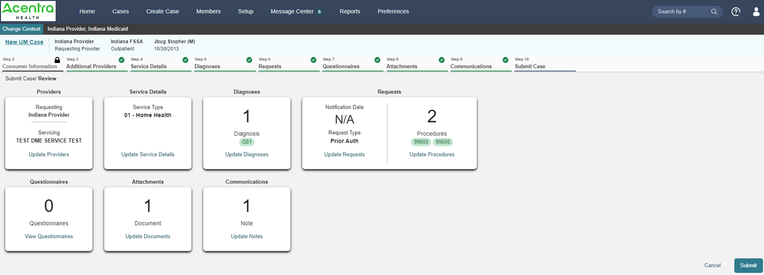

Lastly the user will select submit. And a disclaimer will pop up. Click agree and the case will submit.
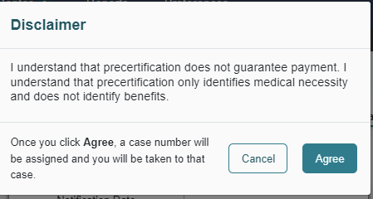
You will then be taken to the landing page of your auth request.
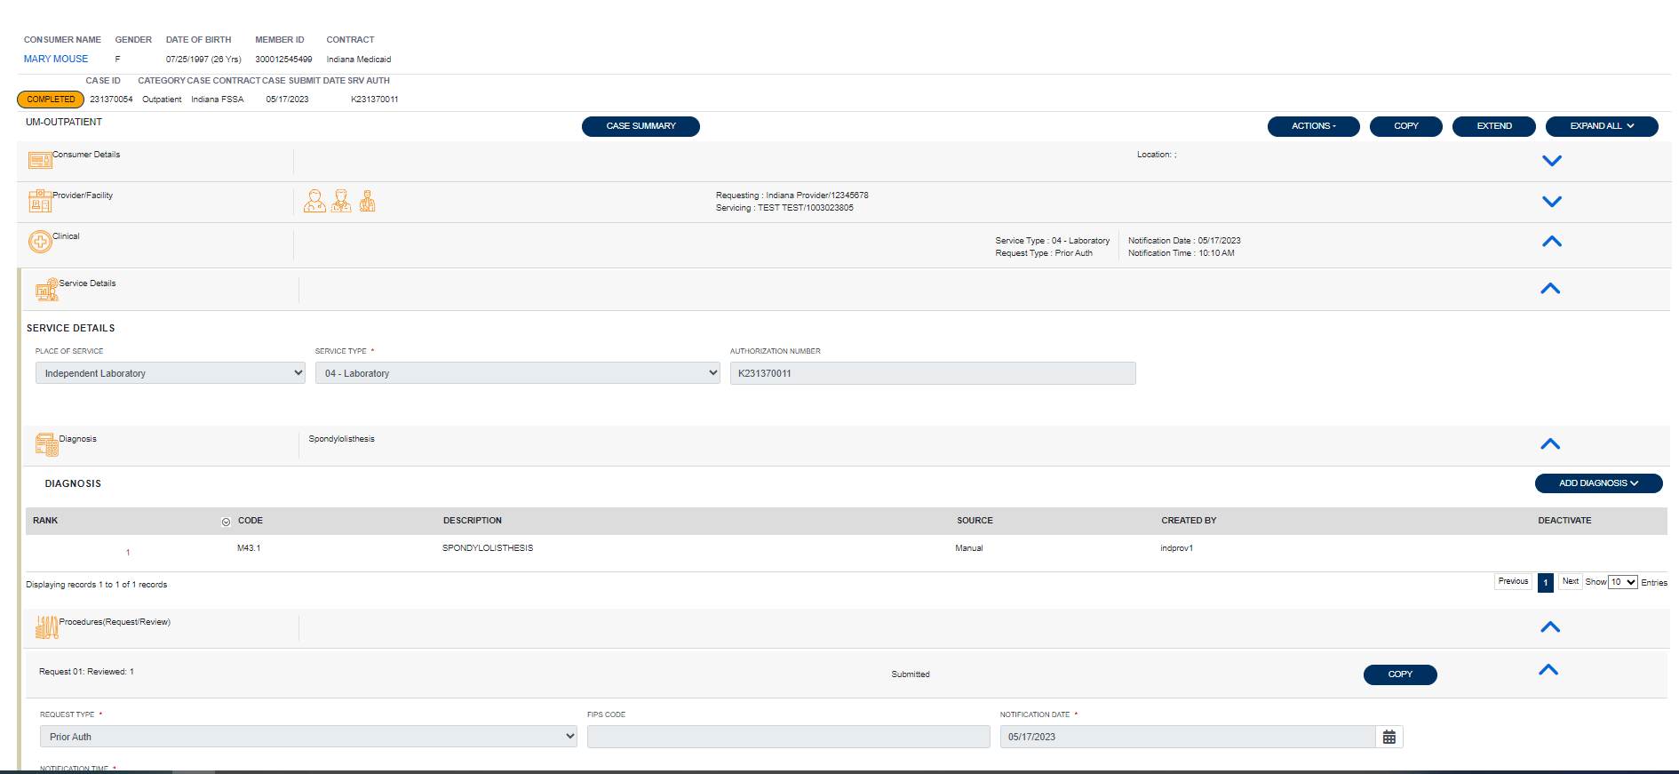

Requesting Additional Units

To request additional units on an existing DOS range, submit this via the actions drop down menu selecting auth revision request. Providers can do this from the case queue or from within the case.
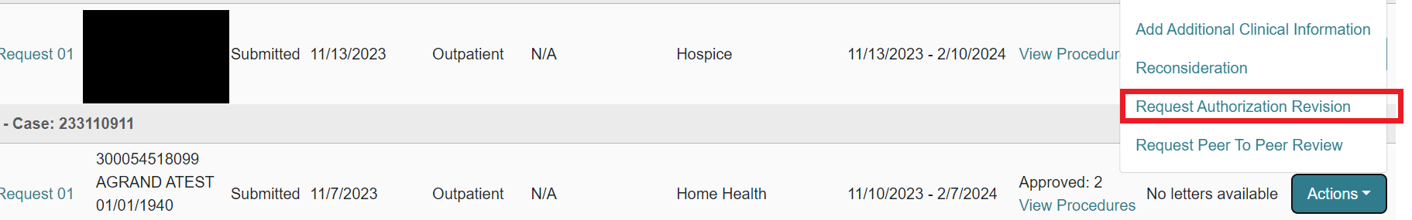

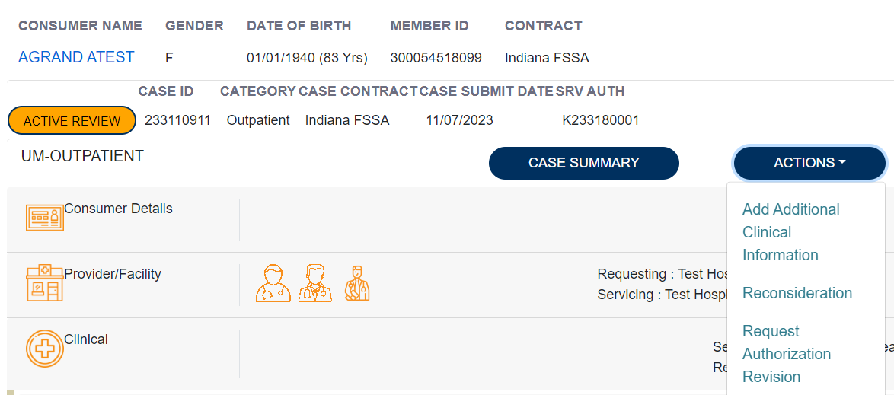
Here, the provider will enter a note outlining the number of units of each code being asked for. And additional documentation should be attached here as well.
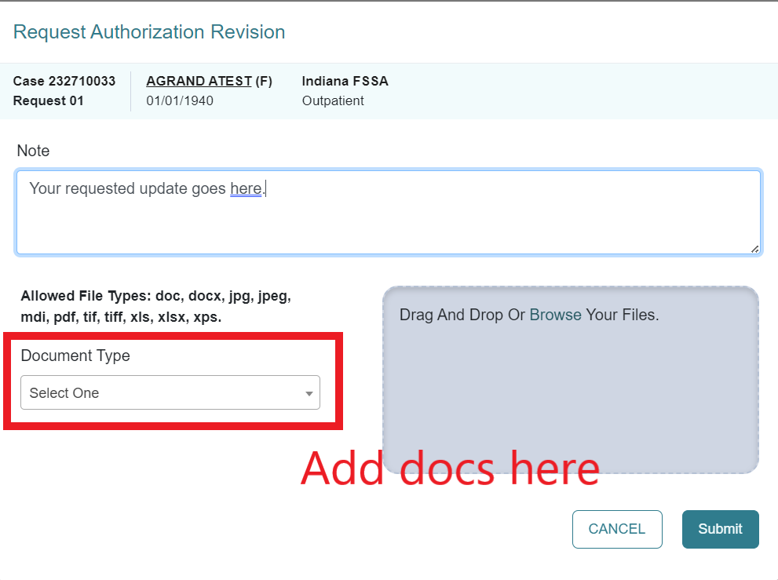
When a provider needs to extend the authorization for new DOS when the authorization has not yet expired, this should be done using the Extend option. Providers can do this from the case queue or from within the case.

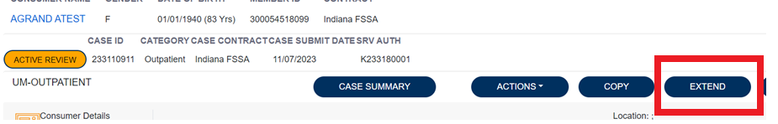

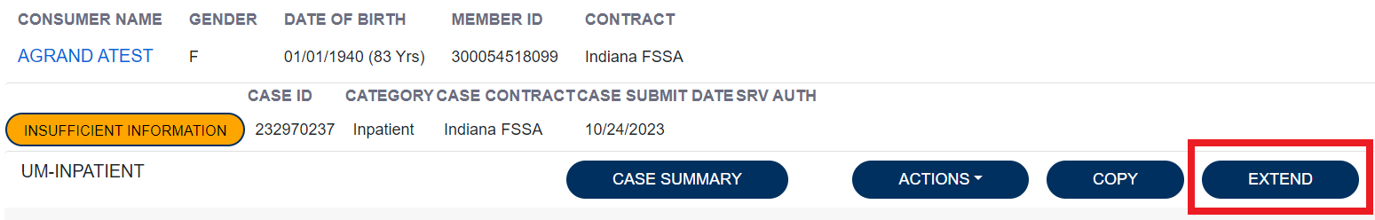
Here, the provider will need to expand the clinical section of the case and enter the quantity and duration in the new request line. And additional documentation should be attached as well.
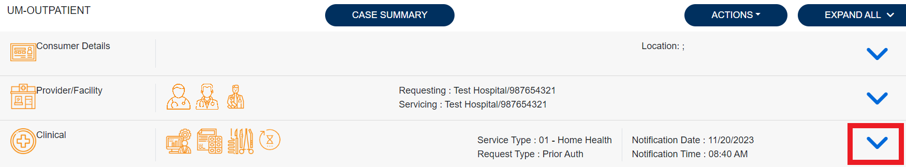
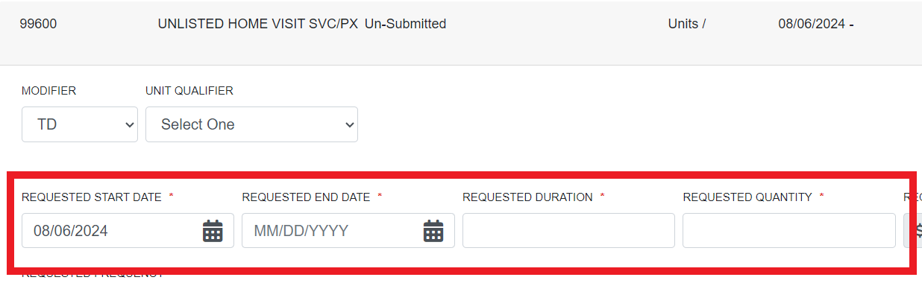
Next the provider will check the box regarding Understanding that the PA is not a guarantee of payment and is for medical necessity only. And then click submit.
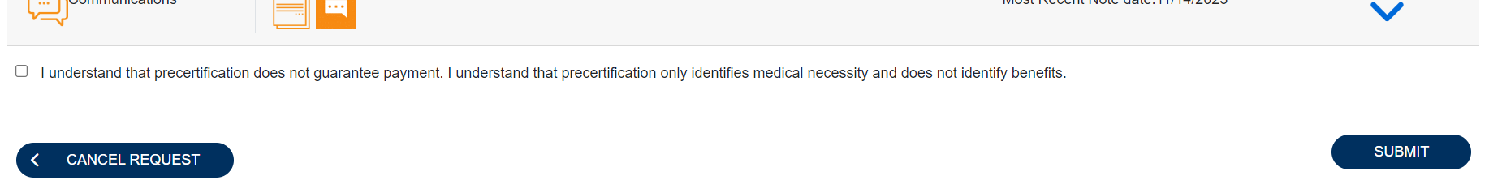

Below are some important links:
Training videos and other materials specific to Indiana Medicaid FFS are available at:
INMedicaidffs | Training Provider Education (kepro.com)
New Provider Portal Link:
https://portal.kepro.com
Standard system training materials are available at the Atrezzo Help site:
https://www.kepro.com/atrezzo-help
FSSA forms link:
https://www.in.gov/medicaid/providers/provider-references/forms/
Modules for providers:
https://www.in.gov/medicaid/providers/provider-references/bulletins-banner-pages-and-reference-modules/ihcp-provider-reference-modules/
Provider Fee Schedules:
https://www.in.gov/medicaid/providers/business-transactions/billing-and-remittance/ihcp-fee-schedules/
Contact Support Center:
• Phone: 866-725-9991-for case specific and clinical submission for PA.
• Fax 800-261-2774- clinical submission for PA.
• INPriorAuthIssues@Acentra.com system access, registration, and submissions issues. This is not monitored for authorizations. Please do not send PHI for case creation or correction. Please do send detailed information about your issue. You can send a member ID, provider ID and Medicaid #, screen shots of any error messages, etc. We do NOT process authorizations in this E-mail.

