Hospice STEP BY STEP PROCESS | A helpful Guide to case submission  Provider Relations  ACENTRA

Go to “Create Case” at the top of the screen. Choose “UM” then “Outpatient”.
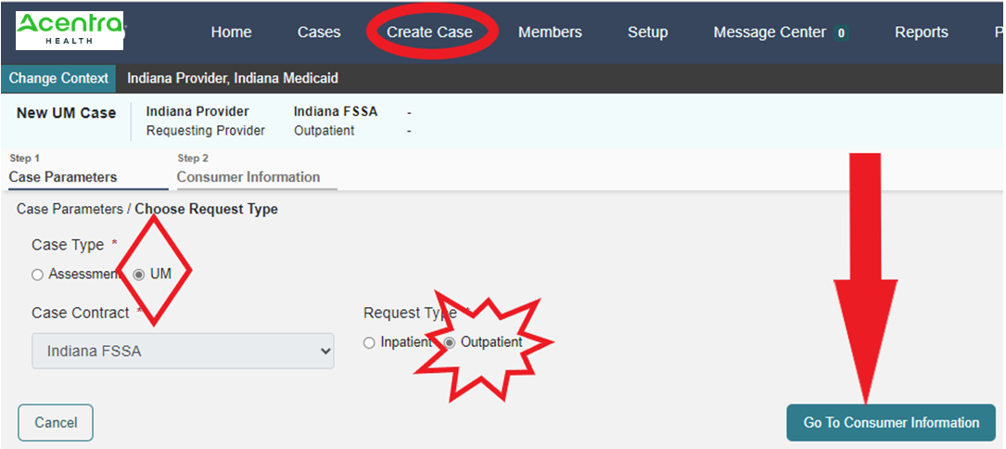

Click Go to Consumer Information. Select by using either the Member/Consumer ID or last name, at least first initial and DOB.
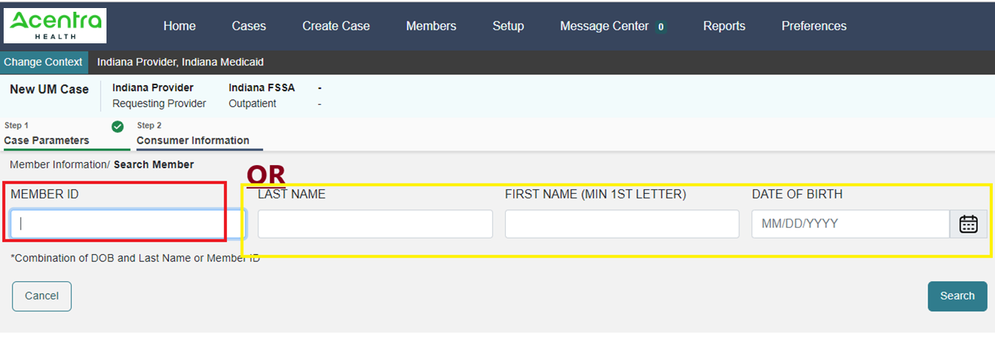
Select the member.
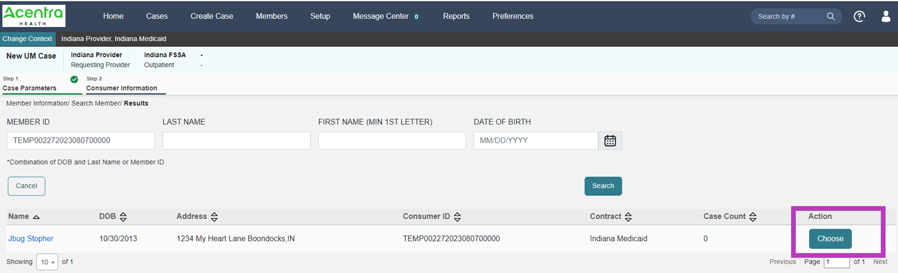

It will display any cases the provider is associated with for that member. If it is not a duplicate, select create case:
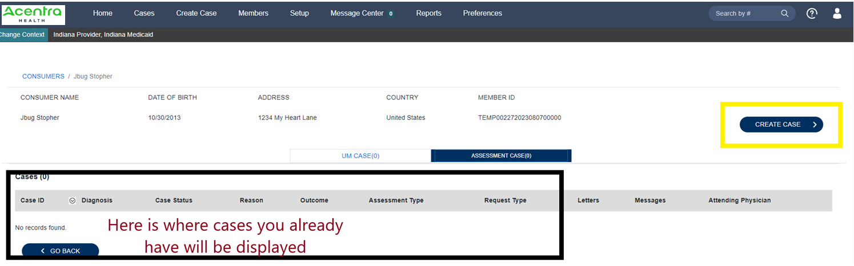
Next is the selected providers. Here the servicing provider can be changed to the group or billing NPI for claims purposes. The case will not be able to be submitted if it is not a group/billing NPI.
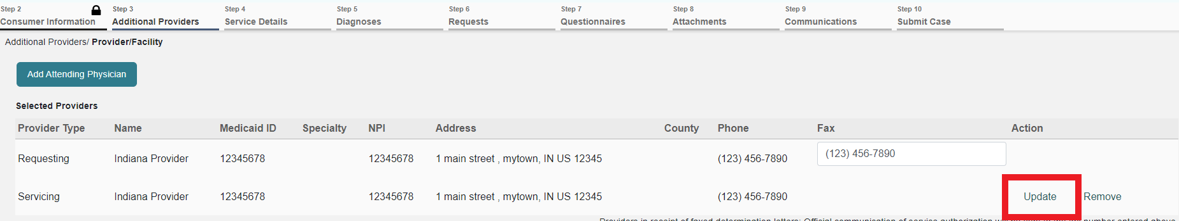
Next select go to services. 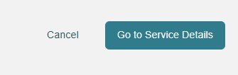
Next select service type. (Only those sections with a red * are required sections). Select Hospice.
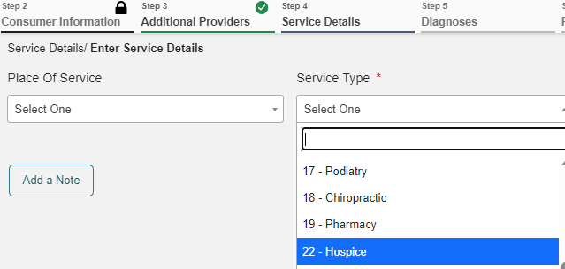

Click “Go to Diagnoses” to move to the next screen.

Enter at least 3 characters for the system to search. Please be patient as it takes a moment to filter.
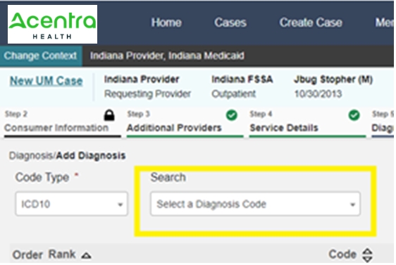
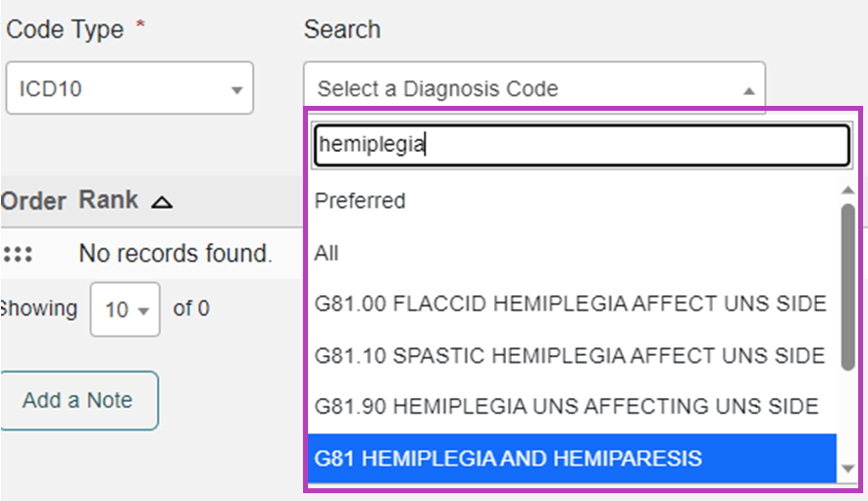
As many diagnoses as needed can be added by using the search window and adding them one at a time.
Next, click go to requests. 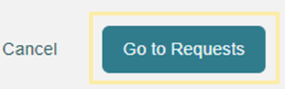

Select “Prior Auth” under “Request Type”. (“Retrospective” if it is a retrospective review).

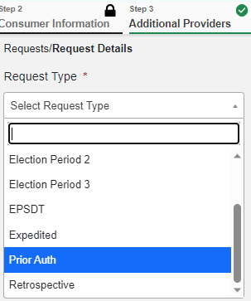

Then Select “Go to Procedures”. 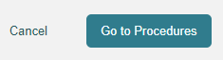

The user will then search the first code they are submitting by clicking in the search box that says, “Search by code or description”. A selection of CPT codes will populate. The user will then select the code needed & after a moment the screen will populate to fill in “Requested Start Date”, “Requested End Date”, “Requested Duration” & “Requested Quantity”. They will get a pop up that reminds the user of forms that may be required.
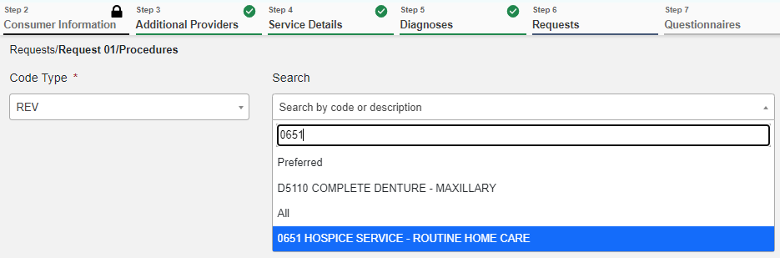
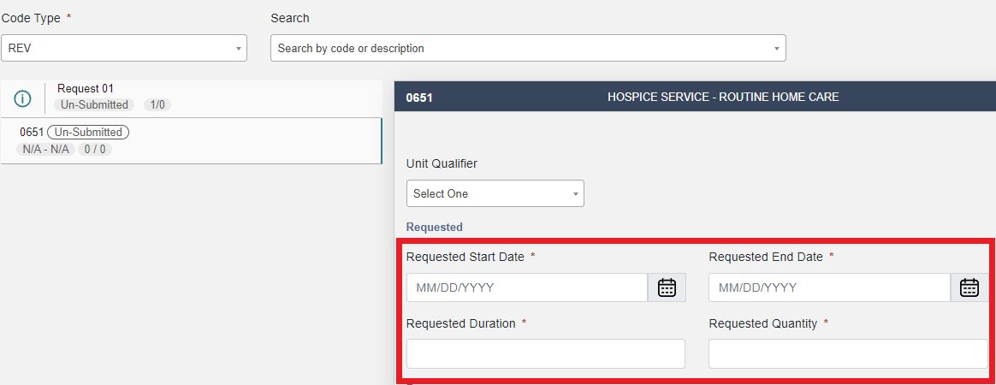

Then select “Go to Questionnaires”.

On the next screen select “Go to Attachments”.

Click “Upload a document”. Select the “Document Type” from the drop down and either “Drag and Drop OR Browse Your Files”. Do this for each document type that needs to be uploaded.
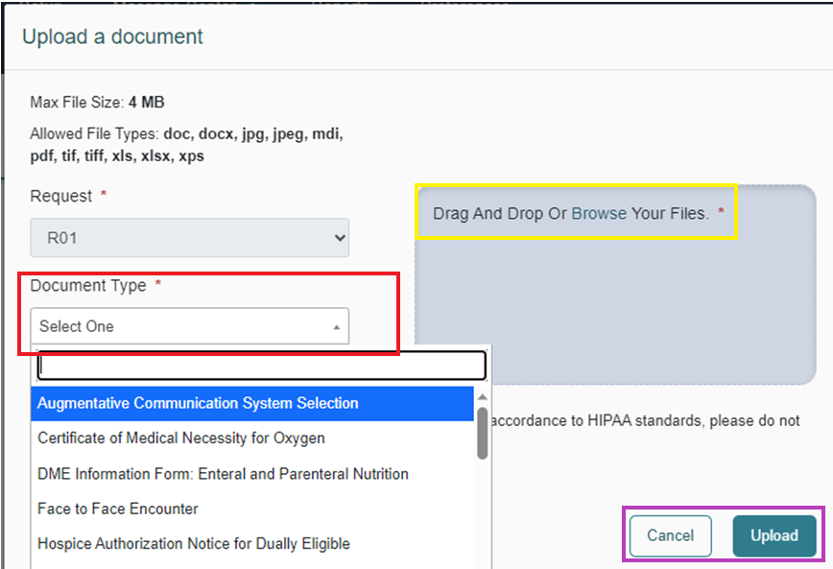
Then select “Go to Communications”.

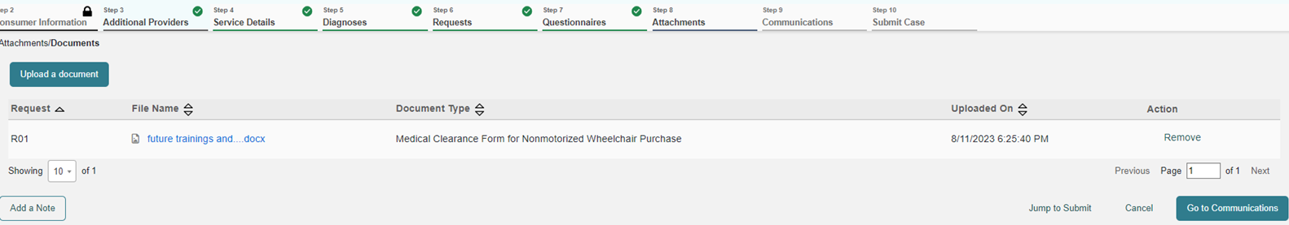

Then “Add a note” if the user feels there is additional information not in the documentation that the reviewer may need to know.
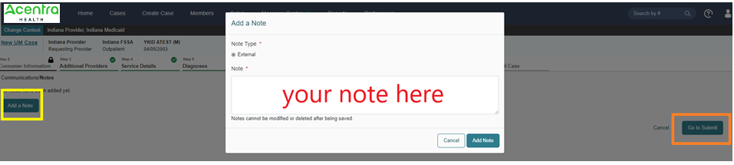

Click “Go to Submit” next.

The user will then see a summary page, where they can update any portion of the submission that does not display correctly. When correct, the user will select submit and the process is completed.
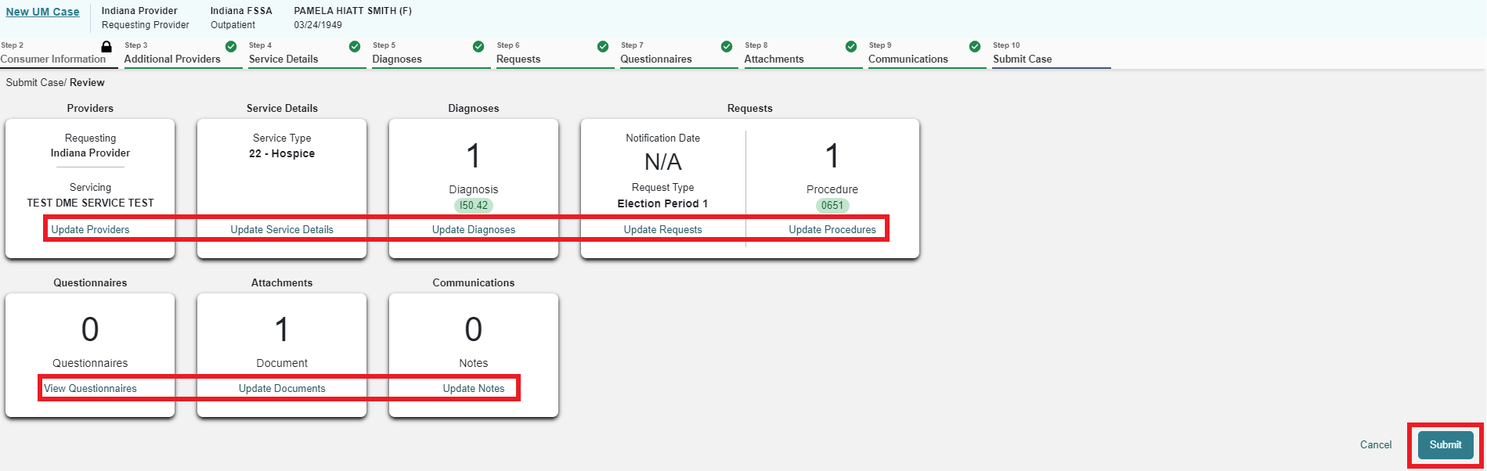

Requesting Subsequent Election Periods

When a provider needs to extend the authorization for new DOS when the authorization has not yet expired, this should be done using the Extend option. Providers can do this from the case queue or from within the case.

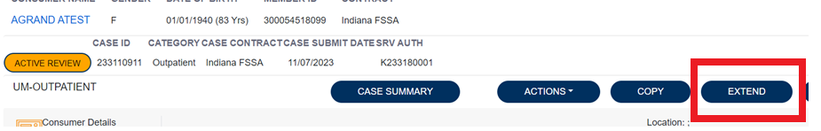

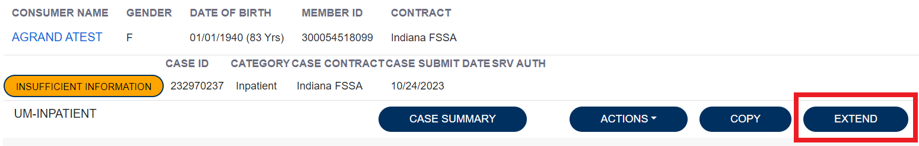
Here, the provider will need to expand the clinical section of the case and enter the quantity and duration in the new request line. And additional documentation should be attached as well. Please verify that the request type is updated and correct.
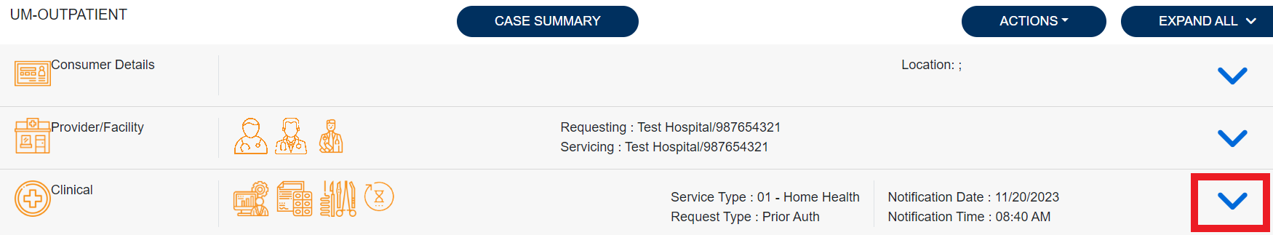
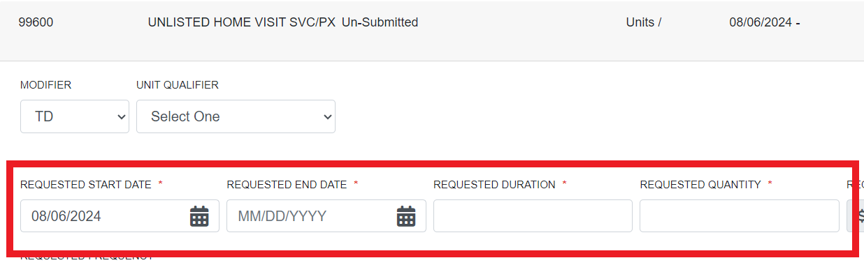
Next the provider will check the box regarding Understanding that the PA is not a guarantee of payment and is for medical necessity only. And then click submit.
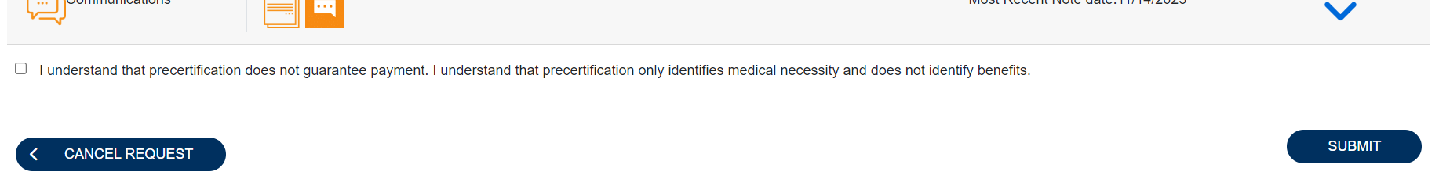

Below are some important links:
Training videos and other materials specific to Indiana Medicaid FFS are available at:
INMedicaidffs | Training Provider Education (kepro.com)
New Provider Portal Link:
https://portal.kepro.com
Standard system training materials are available at the Atrezzo Help site:
https://www.kepro.com/atrezzo-help
FSSA forms link:
https://www.in.gov/medicaid/providers/provider-references/forms/
Modules for providers:
https://www.in.gov/medicaid/providers/provider-references/bulletins-banner-pages-and-reference-modules/ihcp-provider-reference-modules/
Provider Fee Schedules:
https://www.in.gov/medicaid/providers/business-transactions/billing-and-remittance/ihcp-fee-schedules/
Contact Support Center:
• Phone: 866-725-9991-for case specific and clinical submission for PA.
• Fax 800-261-2774- clinical submission for PA.
• INPriorAuthIssues@Acentra.com system access, registration, and submissions issues. Please send detailed information about your issue. You can send a member ID, provider ID, screenshots of any error messages, and any information you feel may help determine the cause of your problem. This is not monitored for authorizations. Please do not send PHI for case creation or correction. We do NOT process authorizations in this E-mail.

