Provider Relations
ACENTRA
Concurrent Review Submissions
Step by Step Instructions
A step-by-step overview of how to submit a concurrent review on your PA.
Next to the Member row you wish to extend, select the actions drop down, then extend. It will ask if you want to extend that record, select yes.

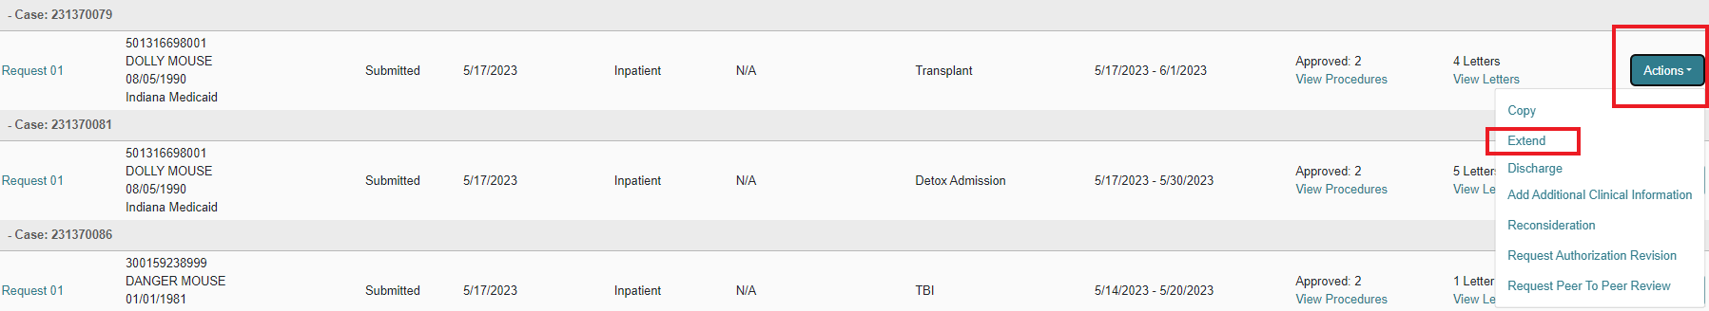

You can either use the expand all button to open all sections at once or you can select the down carat for the sections you need to access.
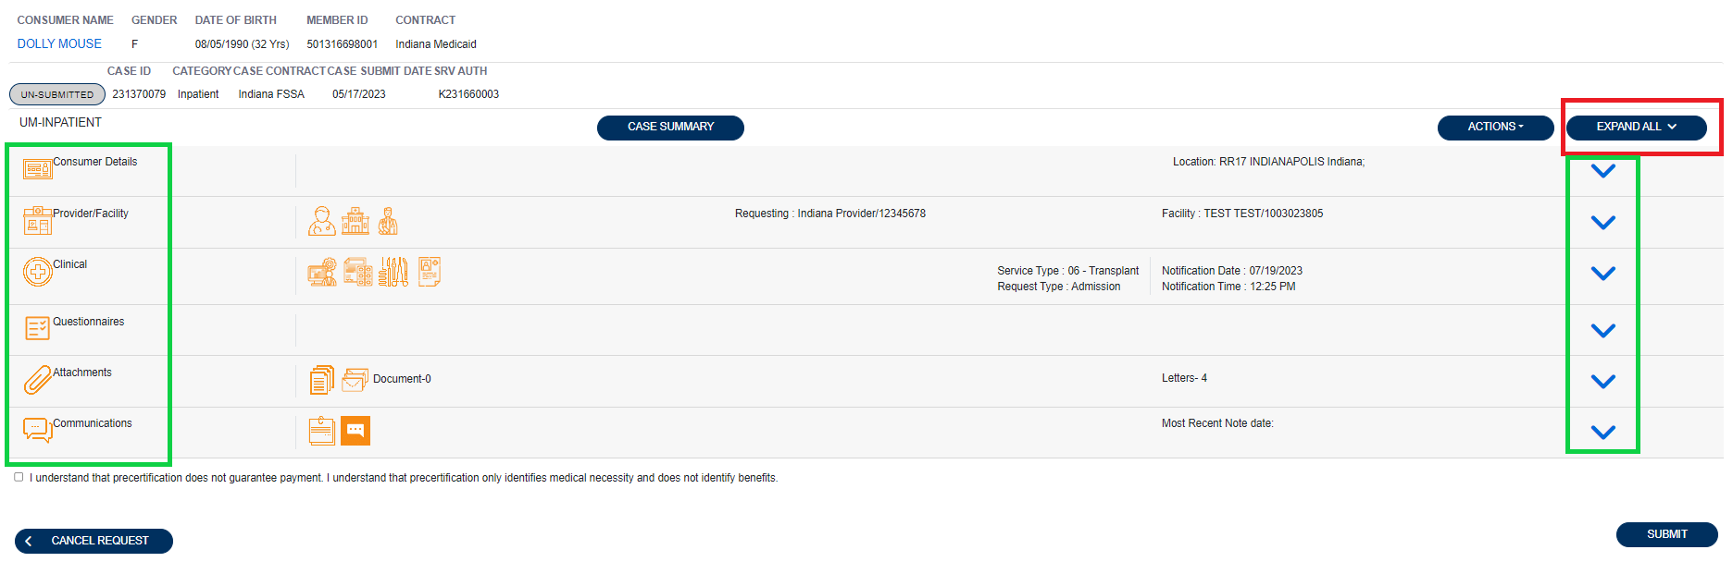
Under the clinical section, you will see a recap of the initial submission information and R01, etc., that have been processed will show but not be expanded. The new request row will be expanded and will show as Un-Submitted.
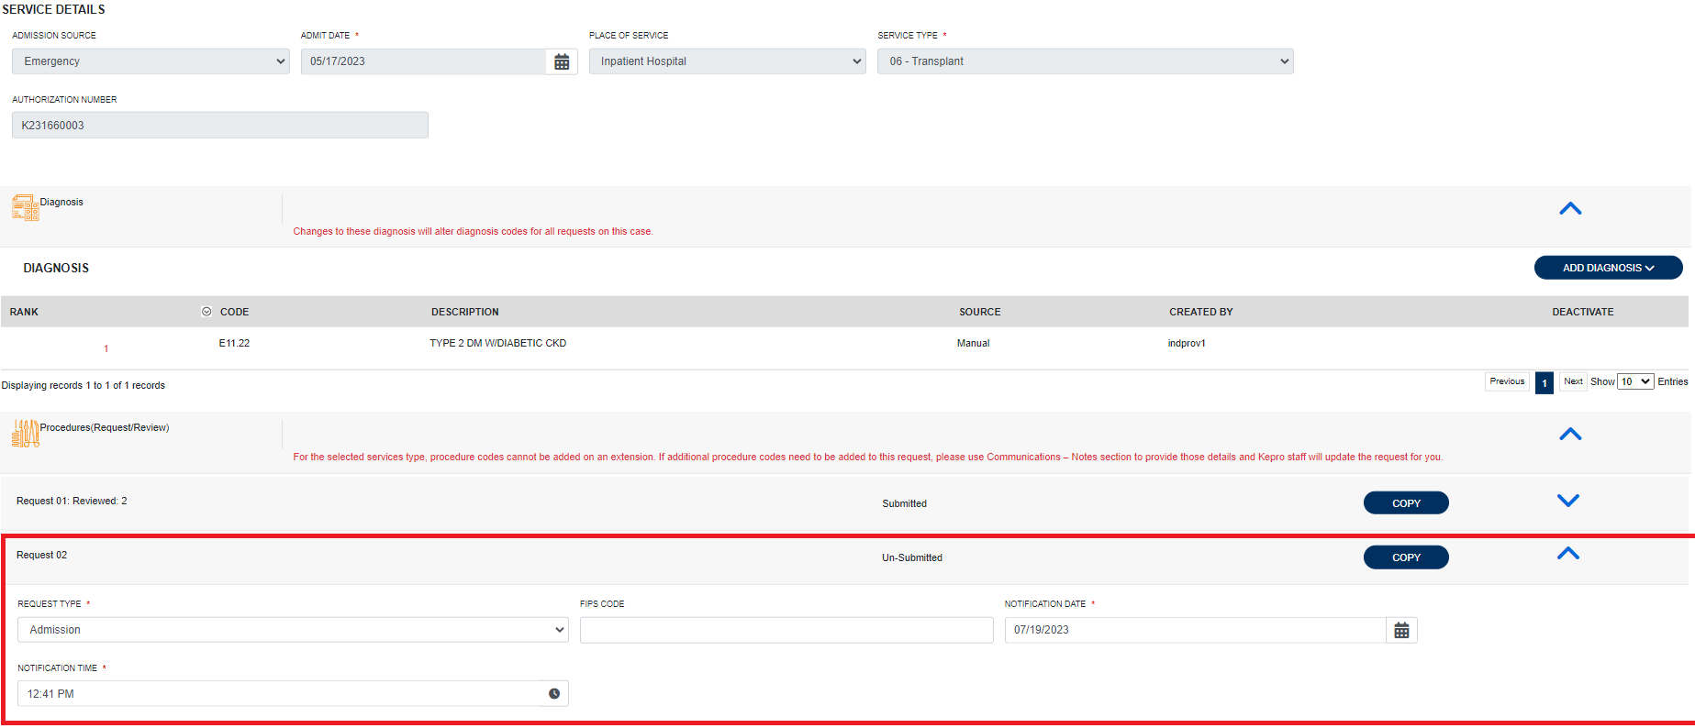
The R02, ETC, will have copied over all the codes from the previous row. If there were procedure codes for procedures already reviewed previously, you can delete those from the concurrent review. (in the example below, I will remove 50360 as it was previously reviewed and approved.) It will ask for a reason, select entered in error and yes when asked if you want to remove it.
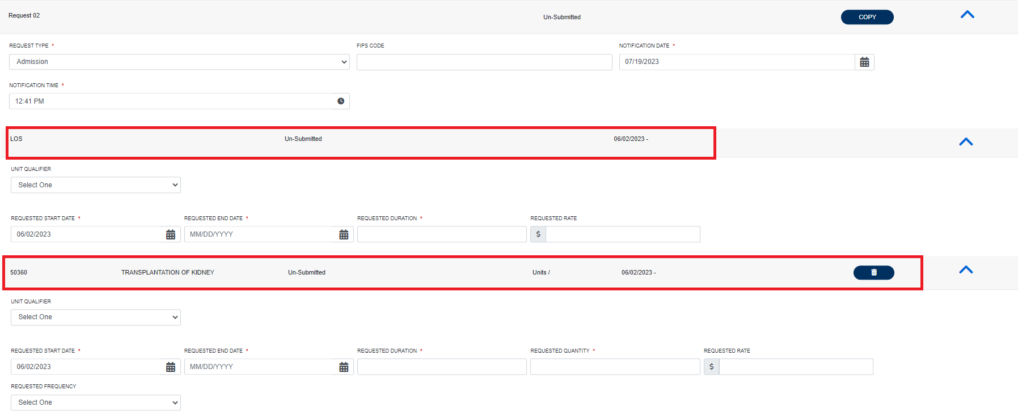
The start date will auto populate with the first non-covered day, and you can either enter an end date or enter a quantity and it will populate the end date automatically.
Under the attachments tab, use the down carat to expand the section, then expand the documents section and select click here to upload file to attach your clinical documentation.

Note that the file limit in our production portal where you work will be 10mb. Mine shows as 4 due to being a training environment.
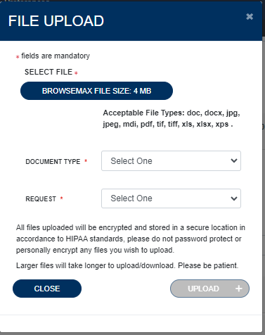
The final section “Communications” is where you can enter any Notes that you need to send to the clinical reviewer to see. The last step is to click accept on the disclaimer notice and submit.
The screen will go back to the overview, and you can now see R02 states submitted.
Your submission is completed.

Below are some important links:

Training videos and other materials specific to Indiana Medicaid FFS are available at:
https://INMedicaidFFS.kepro.com
New Provider Portal Link:
https://portal.kepro.com
Standard system training materials are available at the Atrezzo Help site:
https://www.kepro.com/atrezzo-help
FSSA forms link:
https://www.in.gov/medicaid/providers/provider-references/forms/
Modules for providers:
Indiana Medicaid: Providers: IHCP Provider Reference Modules
Provider Fee Schedules:
Indiana Medicaid: Providers: IHCP Fee Schedules

Contact Support Center:
• INPriorAuthIssues@Acentra.com
• Phone: 866.725.9991
• Fax 1-800-261-2774

